Name: Aarya Tiwari

Roll No. 16010421119

Batch B2

CP TUT 7/2/23

CODE;-

#include<iostream>  
using namespace std;  
  
class Node {  
    public:  
    int data;  
    Node \*next;  
  
    Node(int x) {  
        this->data = x;  
       this->next=0;  
    }  
};  
void printLL(Node \*head) {  
    while(head) {  
       cout<<head->data<<" ";  
        head = head->next;  
    }  
}  
  
Node\* reverse(Node\* head) {  
    if(!head->next) return head;  
    Node \*curr=head,\*prev=0,\*next=head->next;  
     
    while(curr && curr->data%2==0 && next && next->data%2==0) {  
       curr->next=prev;  
        prev=curr;  
        curr=next;  
        next = next->next;  
    }  
  
    if(prev && prev->data%2==0 && curr && curr->data%2==0) {  
        curr->next = prev;  
    }  
    if(next) head->next = reverse(next);  
    return curr;  
}  
  
int main() {  
    int N;  
    cout<<"Enter the size: ";  
    cin>>N;  
    cout<<"Enter the data: ";  
    int temp;  
    cin>>temp;  
    Node \*head = new Node(temp), \*tmp;  
    tmp=head;  
    for(int i=1;i<N;i++) {  
  
       cin>>temp;  
  
        tmp->next = new Node(temp);  
  
       tmp=tmp->next;  
  
    }  
  
    cout<<endl;  
    cout<<"Linkedlist Before: ";  
    printLL(head);  
  
    head = reverse(head);  
    cout<<endl;  
    cout<<"Linkedlist After: ";  
    printLL(head);  
  
}

OUTPUT

1

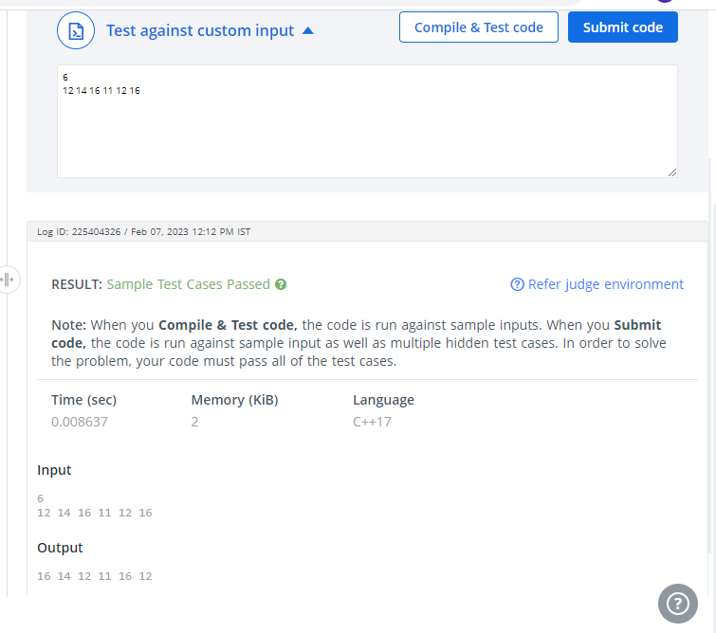

2

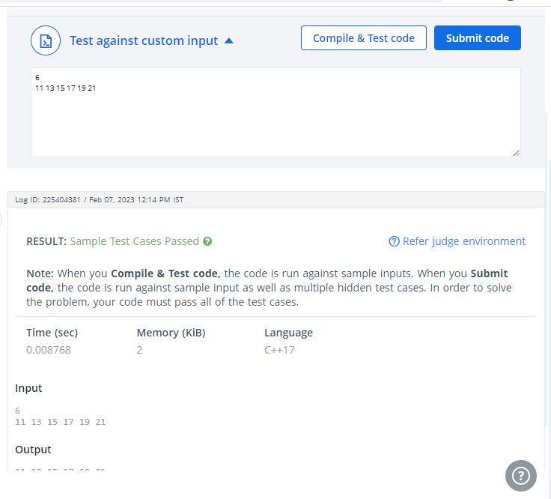

3

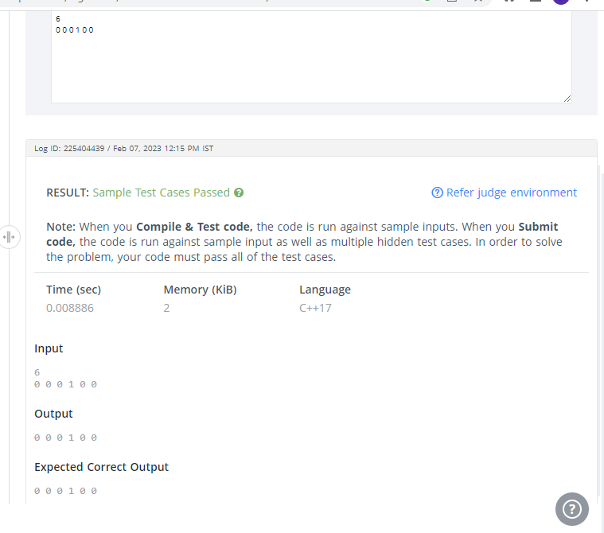

4

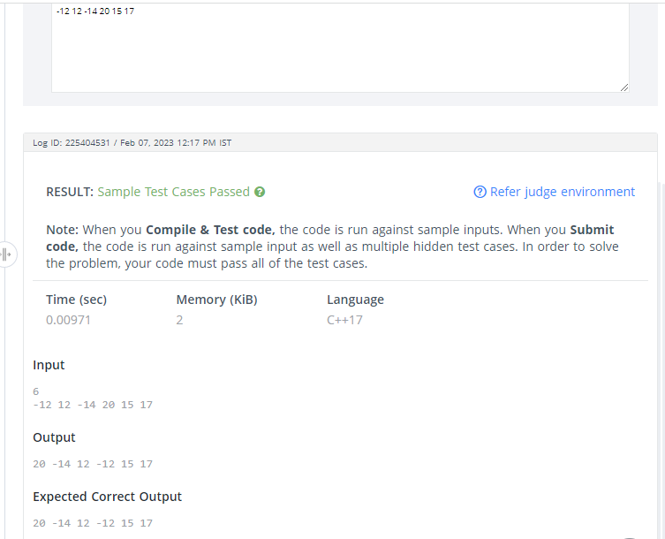

5

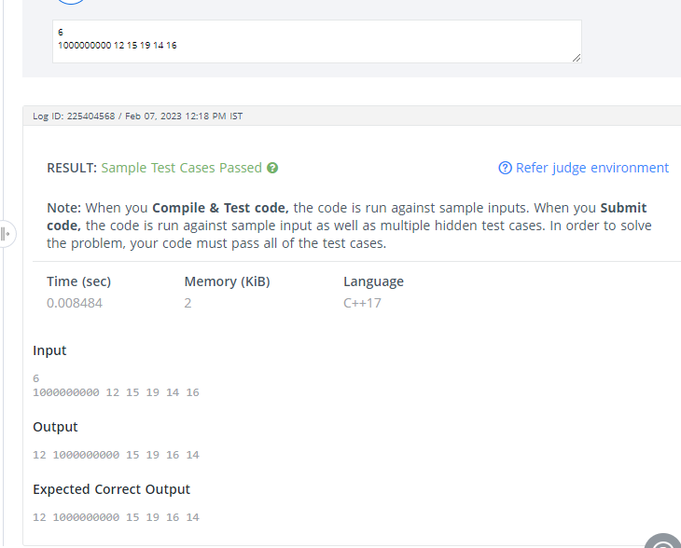

6

